|  |
| --- |
| What: meeting the other staff members, making posters for registration and the summer assignment! **If you cannot attend please see:**Mrs. Zotos Rm. 113 **CONGRATULATIONS!!** You have been selected to be a part of Yearbook! The fun will begin on  **Date:**  **Time:**  **Where:** Room 113  **YOU MADE IT!** **YEARBOOK** |
|  |
| |  | | --- | | What: meeting the other staff members, making posters for registration and the summer assignment! **If you cannot attend please see:**Mrs. Zotos Rm. 113 **CONGRATULATIONS!!** You have been selected to be a part of Yearbook! The fun will begin on  **Date:**  **Time:**  **Where:** Room 113  **You Made it!****YEARBOOK** |   **Marisela Delayo-Fierro** **If you cannot attend please see:**Mrs. Zotos Rm. 113/321(after school)**YEARBOOK** **CONGRATULATIONS!!** You have been selected to be a part of Yearbook! The fun will begin on  **Date: 5/26**  **Time: 3:15**  **Where:** Room 321  **You Made it! it!** |
| **You Made it!****If you cannot attend please see:**Mrs. Zotos Rm. 113/321(after school)**YEARBOOK** **Genessis Meza**  **CONGRATULATIONS!!** You have been selected to be a part of Yearbook! The fun will begin on  **Date: 5/26**  **Time: 3:15**  **Where:** Room 321 |
| **Galinda Villegas**  **CONGRATULATIONS!!** You have been selected to be a part of Yearbook! The fun will begin on  **Date: 5/26**  **Time: 3:15**  **Where:** Room 321 **You Made it!****YEARBOOK****If you cannot attend please see:**Mrs. Zotos Rm. 113/321(after school) |

#### **You Made it!**

### **YEARBOOK**

##### **If you cannot attend please see:**

##### Mrs. Zotos Rm. 113/321(after school)

**Bertha Plascencia**

**CONGRATULATIONS!!** You have been selected to be a part of Yearbook! The fun will begin on

**Date: 5/26**

**Time: 3:15**

**Where:** Room 321

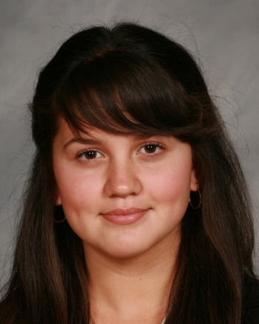

**Julia Natividad**

#### **You Made it!**

### **YEARBOOK**

##### **If you cannot attend please see:**

##### Mrs. Zotos Rm. 113/321(after school)

**CONGRATULATIONS!!** You have been selected to be a part of Yearbook! The fun will begin on

**Date: 5/26**

**Time: 3:15**

**Where:** Room 321

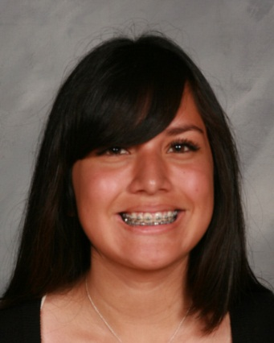

#### **You Made it!**

### **YEARBOOK**

##### **If you cannot attend please see:**

##### Mrs. Zotos Rm. 113/321(after school)

**Cynthia Munoz**

**CONGRATULATIONS!!** You have been selected to be a part of Yearbook! The fun will begin on

**Date: 5/26**

**Time: 3:15**

**Where:** Room 321

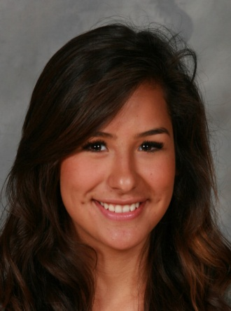

**Jocelyn Carmona**

**CONGRATULATIONS!!** You have been selected to be a part of Yearbook! The fun will begin on

**Date: 5/26**

**Time: 3:15**

**Where:** Room 321

### **YEARBOOK**

##### **If you cannot attend please see:**

##### Mrs. Zotos Rm. 113/321(after school)

##### **If you cannot attend please see:**

##### Mrs. Zotos Rm. 113/321(after school)

### **YEARBOOK**

#### **You Made it!**

**CONGRATULATIONS!!** You have been selected to be a part of Yearbook! The fun will begin on

**Date: 5/26**

**Time: 3:15**

**Where:** Room 321

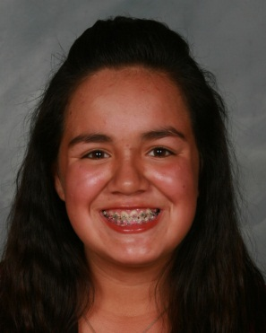

**Jessica Walker**

#### **You Made it!**



**Sandra Carlos**

##### **If you cannot attend please see:**

##### Mrs. Zotos Rm. 113/321(after school)

### **YEARBOOK**

**CONGRATULATIONS!!** You have been selected to be a part of Yearbook! The fun will begin on

**Date: 5/26**

**Time: 3:15**

**Where:** Room 321

#### **You Made it!**

