Yearbook Buddy Pages FOR SALE!
Split a page with your friends!
10 friends | $30.00 each
9 friends | $33.33 each
8 friends | $37.50 each
7 friends | $42.86 each
6 friends | $50.00 each
FULL PRICE IS $300.00 (limited space)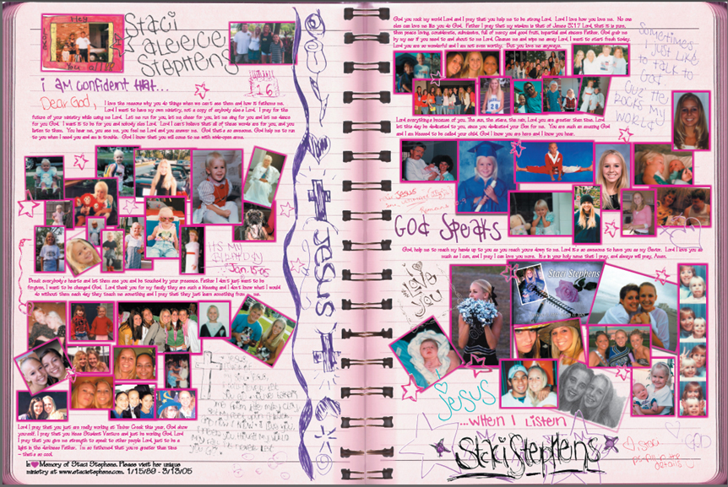
Make your payment in ASB.
Submit pictures/text/design to Room 113-Mrs. Zotos by 3/1.

